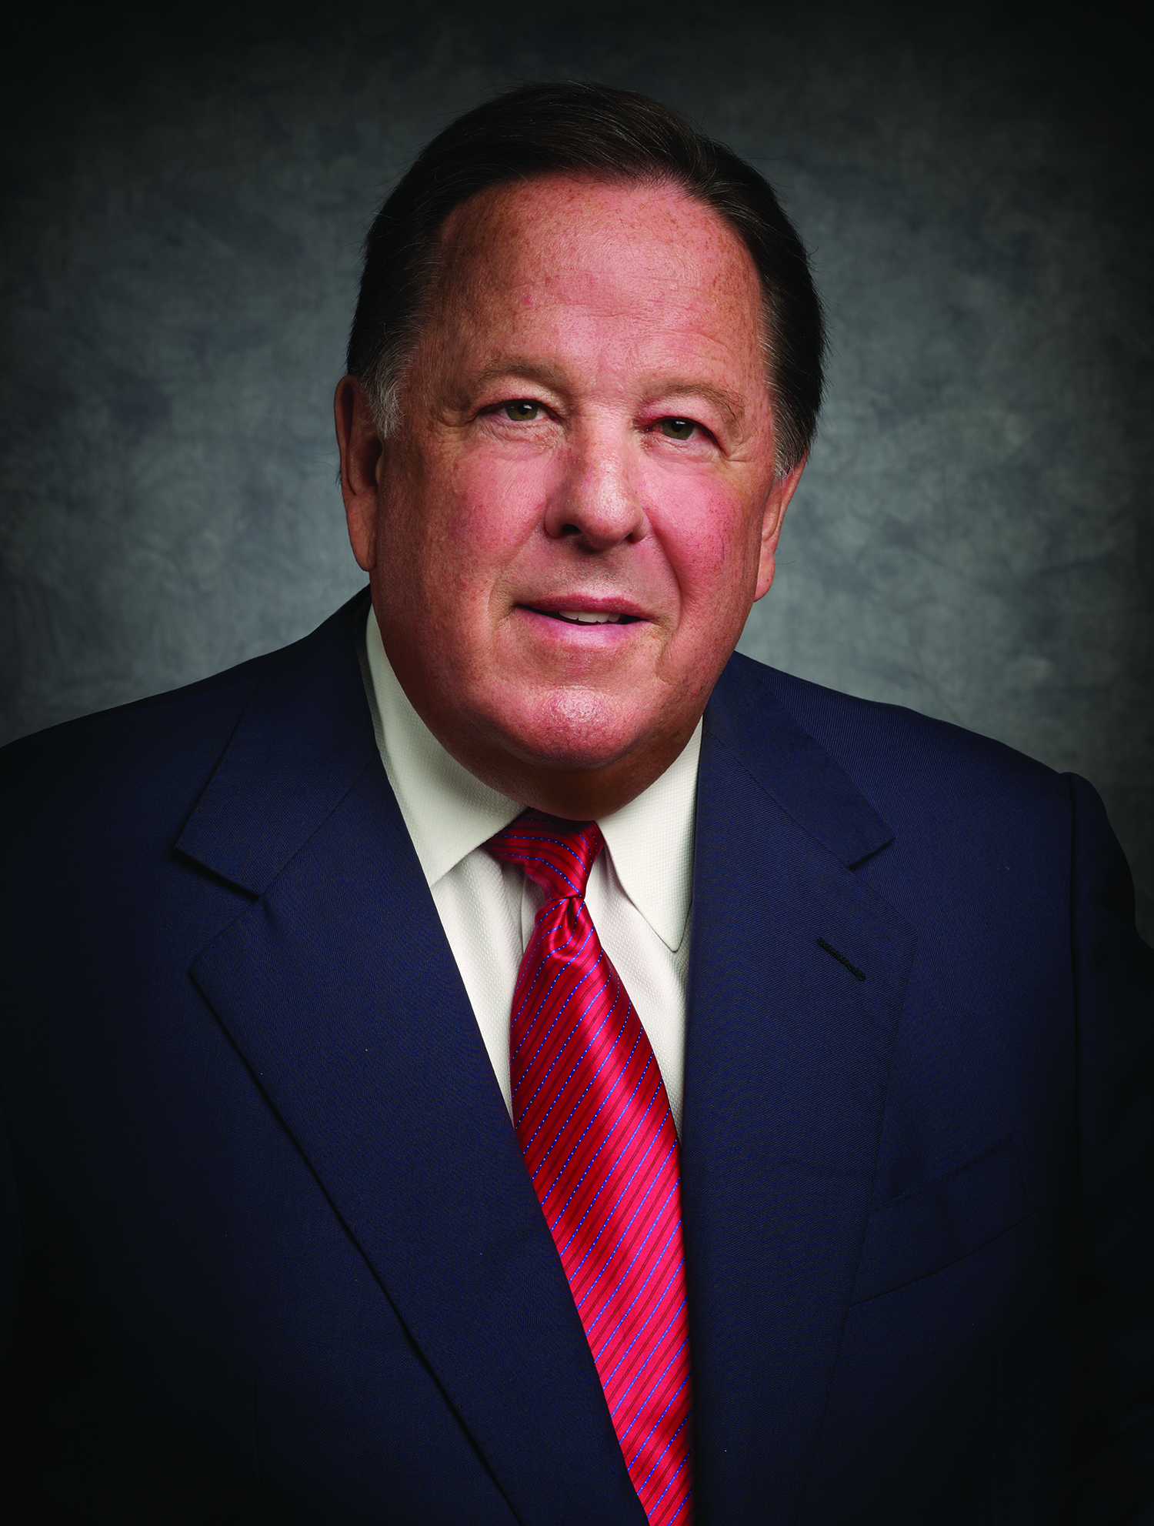Mr. Alan B. White is the Chairman and Chief Executive Officer at PlainsCapital Corporation, which he founded in 1987. Mr. White leads PlainsCapital Corporation’s strategic direction while overseeing the Corporation’s financial strength, stability and management. He continues to drive the Corporation’s unprecedented growth. Additionally, he serves as chairman of PlainsCapital Bank, PlainsCapital Securities LLC, PlainsCapital Equity and PlainsCapital Insurance Services LLC boards of directors; as vice chairman of Hilltop Holdings Inc.; and serves on the boards of directors of FirstSouthwest Holdings LLC, PrimeLending and PlainsCapital Bank Lubbock.

Mr. White is a visionary entrepreneur and tireless community leader. He champions PlainsCapital’s relationship-focused approach to delivering financial services. Mr. White has received numerous awards including the 2013 Robert H. Dedman Lifetime Achievement Award in Philanthropy by the Boys & Girls Clubs of Greater Dallas. He was named one of the Top 100 Most Influential Citizens of the Past 100 Years by the *Lubbock Avalanche Journal* in 2008. Mr. White served on the Super Bowl XLV Host Committee board of directors; the North Texas NCAA Men’s Final Four Committee board of directors; the Cotton Bowl Athletic Association board of directors; and is an MD Anderson Cancer Center Living Legend Committee member among other affiliations. Mr. White holds a Bachelor of Business Administration degree in Finance from Texas Tech University.